ASSIGNMENT 2:

For Assignment 2, the task is to analyse a set of data using SPSS so that you can answer questionsthat test your understanding of statistical principles, techniques, and interpretation. There is achoice of 2 assignment topics, each of which has a data set and an associated document indicatingthe assignment requirements (see Table 1).

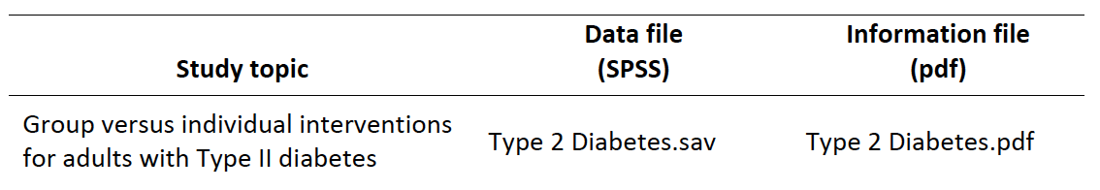

For Assignment 2, the task is to analyse a set of data using SPSS so that you can answer questions that test your understanding of statistical principles, techniques, and interpretation. There is a choice of 2 assignment topics, each of which has a data set and an associated document indicating the assignment requirements (see Table 1).

Assignment length:
The maximum length is 1700 words, including statistics reported in the text (but not including
tables, figures or the appendix). About 7‐8 pages of text is enough for a very good report. Aim to do a thoughtful but concise job. Padding, irrelevancy, and repetition will reduce your mark. There are a few pointers later about how to write concisely.

Interpreting the results.
For the assignment, the discussion of results should include a conceptual interpretation. We do research, or read published research, so that we learn something that we didn’t know before. What we learn is more than mere statistics. Discuss what the results mean, why they might have occurred, and their main implications(s). Also, do they matter? The interpretations or explanations don’t have to be very elaborate, or include formal psychology concepts. However, they should be plausible and thoughtful.

Although the data for these studies were made up, the topics are loosely based on real issues in
Psychology. It will help if you imagine that they are real studies and put yourself in the position of the researcher who conducted the study. Think about what the study was trying to achieve and
what the most take‐home important message(s) might be.

Do you need to do consult any published research on your study topic for Assignment 2?
No. As all of the studies were made up, and all of them consider a novel question rather than being based on previous research, there isn’t any relevant research. The assignment is designed to have students think for themselves about why the results might have occurred and what the study
contributes to knowledge.

